National Fireworks Association
Consumer Fireworks Identification Guide 2026 Edition rev. 3.5.26
Disclaimer: This guide is written as a general resource to retail fireworks business owners, stand or location managers/staff and enforcement officials to help better understand the general national legalities and requirements pertaining to consumer fireworks. The purpose of this document is to aide users in becoming more knowledgeable about identifying fireworks permissible for retail sales to the general public and fireworks not permissible for retail sales to the general public. Individual states and municipalities may have further restrictions over and above those discussed within this document. Any person(s) involved in the retail sale of consumer fireworks is responsible for obeying the laws applicable to their individual location.
Changes at the federal level regarding 1.4G and 1.4S fireworks classifications have made identifying “Consumer Fireworks” permissible for sale to the general consumer public versus “Professional Use Only” and “Articles Pyrotechnic” fireworks not permissible for sale to the general consumer public, more important than ever before. This document is produced with the intent to better aide users in identifying these differences and is being provided as a service to both enforcement authorities and the consumer fireworks retail industry as an information source. It is not intended to, nor does it carry with it any force of authority or law, either assumed or unassumed, relative to consumer fireworks. It is essential to check the laws in your specific area before selling or using fireworks to ensure that you are operating within the requirements of any local laws of the jurisdiction(s) you are operating in.
Section 1 - Definitions
Articles Pyrotechnic - this means any properly classed UN0431, 1.4G or UN0432, 1.4S, labelled item that is available for sale to someone meeting the definition of professional or licensed professional as defined in this document.
Consumer Fireworks – this means any properly classed UN0336, 1.4G and UN0337, 1.4S, item that is labelled in accordance with the requirements set forth in 16 CFR and is available for sale to the general consumer public. Novelty fireworks devices are considered Consumer Fireworks.
Hazard Classification – UN0336, 1.4G, UN0337, 1.4S, UN0431, and UN0432, (1.4G, and 1.4S) are transportation classifications designated by PHMSA/DOT and encompass various types of Fireworks.
Licensed Professional – this means anyone that holds a State approved Pyrotechnic/Shooter’s license or an officially accepted document to meet equivalency. This would include certifications such as the PGI Certified Pyrotechnician License or other such license(s) as determined required by a state or local AHJ to perform professional fireworks display shows for the public. Typically, but not always, such a person will be affiliated with a licensed pyrotechnic display company that will ensure that the individual’s required BATFE licensing requirements have been met.
Novelties – Small pyrotechnic devices that have relatively limited effects. Some common legal consumer items that fall into the novelty category are sparklers, snap pops and some noisemakers. Many times, novelties will be a device that does not have an ignition fuse.
Professional – With regard to those individuals who may possess, or use, “Articles Pyrotechnic” or “Professional Use Only Fireworks” as defined herein, and unless a particular AHJ has a more restrictive definition or requirement, this means anyone who meets the NFA definition of Professional as follows:
NFA Announces Their Definition of Professional Use Only for Pyrotechnics and Fireworks – August 1, 2022
- The requirement for Professional is met by a person when they have the necessary knowledge through education, skill, training, demonstration, and/or prior experience to safely, legally, and responsibly use articles pyrotechnic or fireworks.
- Professional use does not require that a person be employed or compensated to use Professional Use Only Fireworks and/or Articles Pyrotechnic products.
- Professional use does not require use to be in commerce and personal entertainment purposes are allowed.
- Professional Use Only Fireworks and/or Articles Pyrotechnic products may not be used by a person that does not have knowledge and training on how to use the products safely, legally, and responsibly unless they are under the direct and continuous supervision of a person meeting the requirements of Professional Use.
- Testing, training, interviewing, a resume review, contacting references, or any other reasonable review process are all acceptable methods of determining if a person has met the requirement of having the knowledge necessary to safely, legally, and responsibly use Professional Use Only Fireworks and/or Articles Pyrotechnic products.
Professional Use Only Firework – this means any properly classed UN0336, 1.4G, labelled item that is available for sale to someone meeting the definition of licensed professional or professional as defined in this document. These are NOT permissible for sale to the general consumer public.
Section 2: Types and Classifications of allowed fireworks
Consumer Fireworks carry a classification of 1.4G, and 1.4S, though not all 1.4G and 1.4S fireworks are legal for sale to the general consumer public. That is why we feel this document is valuable. We will reference this repeatedly in the upcoming sections.
For purposes of this document, we will be covering the following fireworks classifications and offering more detail in the body of this document:
- UN0431, 1.4G or UN0432, 1.4S Articles Pyrotechnic - should never be sold to consumers or offered for sale in a traditional retail setting.
- UN0336, 1.4G Professional Use Only Fireworks - should never be sold to consumers or offered for sale in a traditional retail setting.
- UN0336, 1.4G or UN0337 1.4S Fireworks – Consumer items approved for sale by the U.S. Consumer Product Safety Commission (CPSC) to consumers in a traditional retail setting.
Section 3 – Labeling and Terms
Perhaps the quickest and easiest way to make proper identification of Consumer Fireworks versus Professional Use Only Fireworks and Articles Pyrotechnic is by identifying the warning labels on the product. These differ between the various products.
For Consumer Fireworks, all warning labels must be easily identifiable and stand out from and be in contrast to the package labelling. A full detailed warning is required on one side of the package. Each of the other sides of the package where the name is present must have a brief warning concluding with “Carefully read other warning on other side” will appear. Examples of these are as follows:
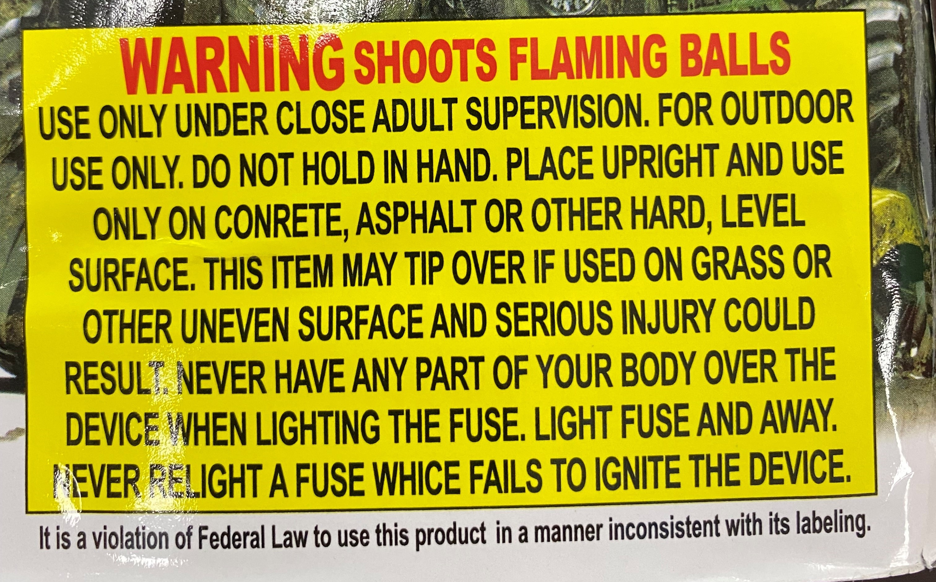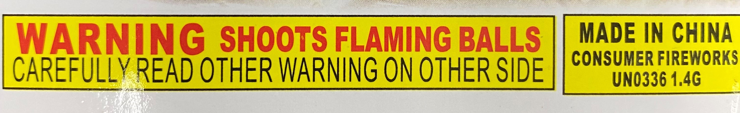
Detailed Warning – Consumer Fireworks Brief Warning – Consumer Fireworks
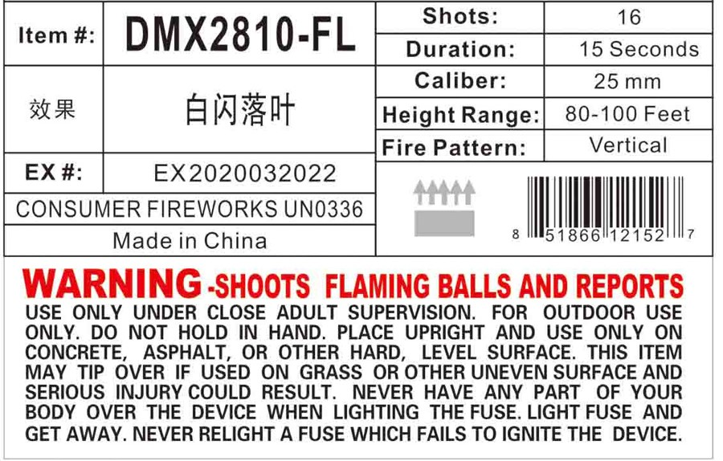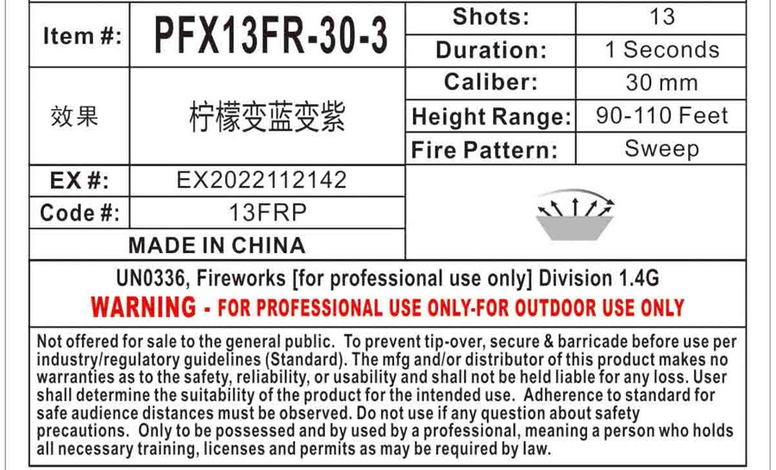
Detailed Warning – Consumer Fireworks Detailed Warning – Professional Use Only Fireworks
The warnings will include a label with a signal word, either WARNING or CAUTION, and have strict guidelines regulated by the CPSC as to what they must contain. For Consumer Fireworks, the labels that start with the word “WARNING” are placed on items where the fireworks effects or the item itself are airborne or eject stars or reports into the air. For reference, these items are considered to be more powerful or potentially more dangerous, thus they bear the wording of “WARNING”.
Labels that start with the word “CAUTION” do not leave the ground or eject reports or flaming balls into the air, emitting showers of sparks only. A statement describing the hazard(s) associated with the device, such as "SHOOTS FLAMING BALLS" or "EMITS SHOWERS OR SPARKS" will follow the words “WARNING” and “CAUTION”, respectively. Information describing further actions will follow this and will include instructions on handling and using the device safely.
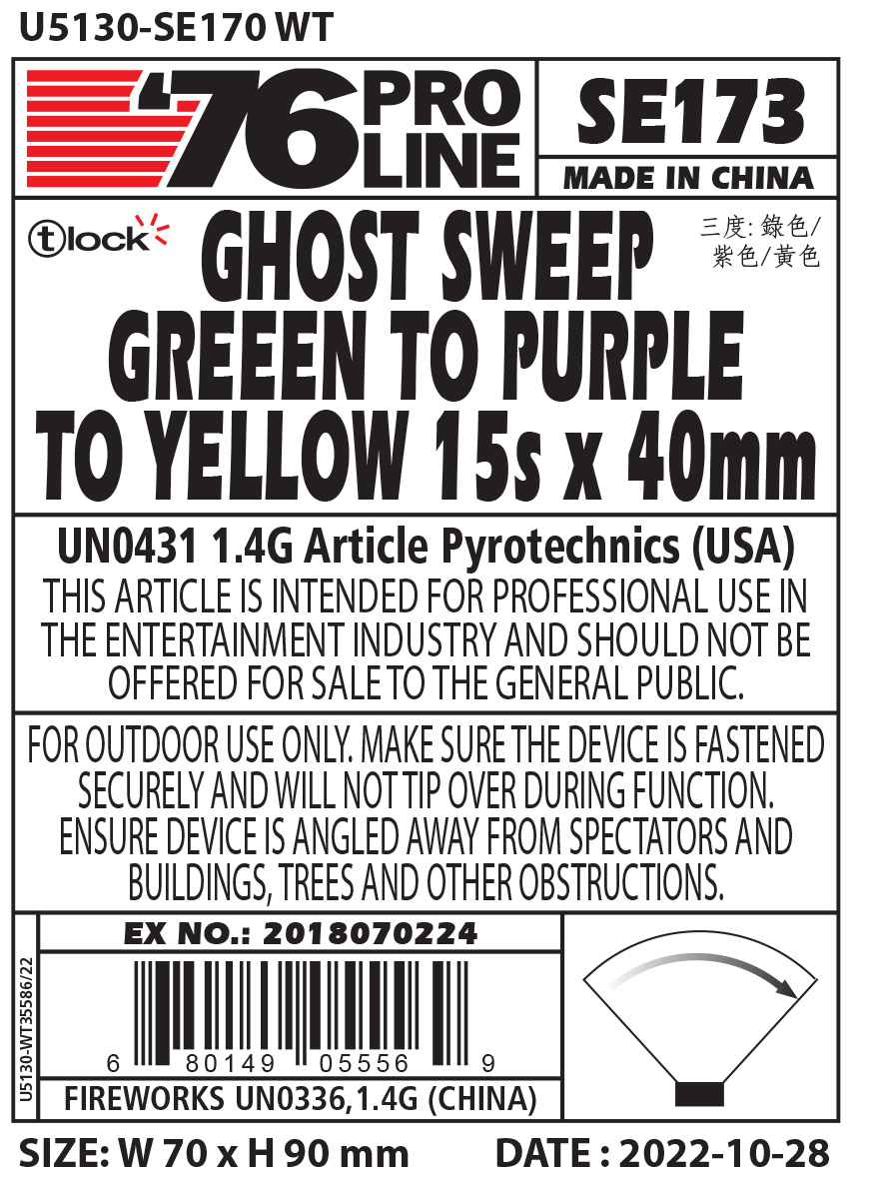
The detailed warning for Professional Use Only Fireworks and Articles Pyrotechnics differs from those used for Consumer Fireworks. There is no regulated mandate as to what the label for Fireworks For Professional Use Only and Articles Pyrotechnics must contain. However, in this example, you will note the language “WARNING – For Professional Use Only”. This must appear on all Professional Use Only Fireworks and Articles Pyrotechnics as exemplified in the images below.
Section 4: Identifying consumer versus non-consumer devices
Generally, consumer legal items will have a colorful label and product name with all the required text and markings listed above in Section 3. However, companies can use a plain-looking wrapper on consumer legal items as well, if all the 16 CFR labeling requirements are met. Professional Use Only Fireworks and Articles Pyrotechnic products will always have a single color plain looking wrapper, with the appropriate text as listed in Section 3 clearly identifying the item as “For Professional Use Only” or “For Professional Use” product. Sometimes, these items also provide further clarification such as “not offered for sale to the general public” and for “outdoor use only.”
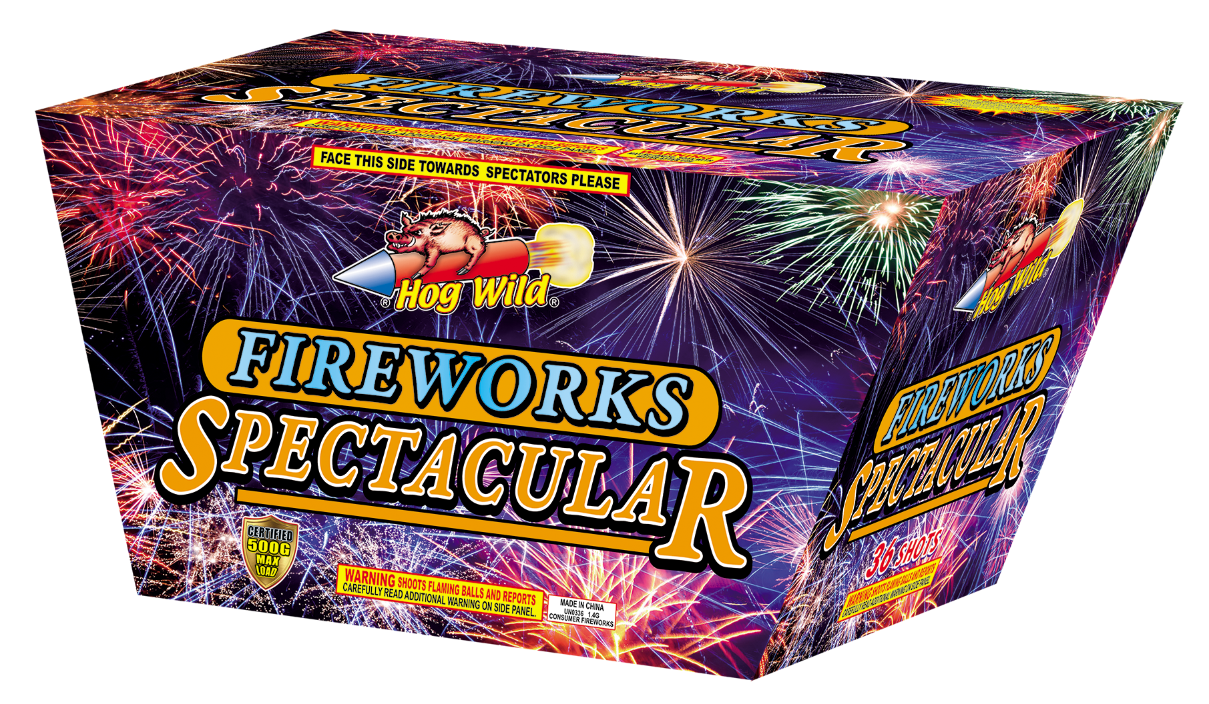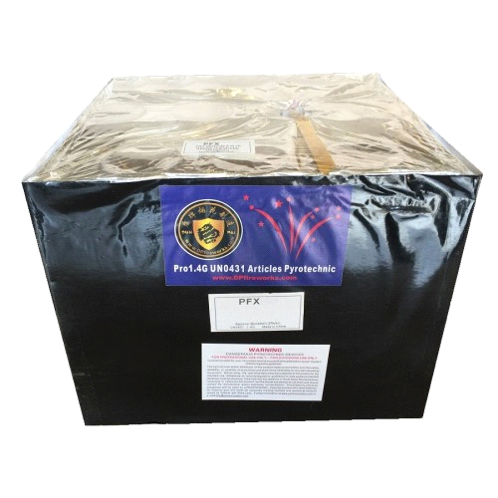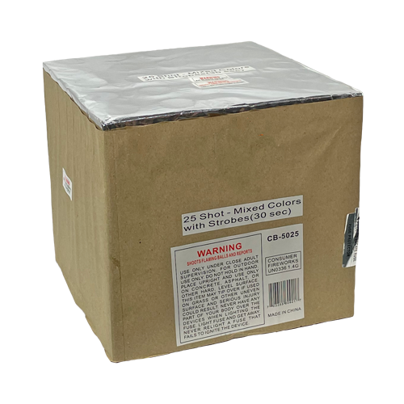
1 Consumer Firework - Cake 2 Professional Use Only Firework - Cake 3 Consumer Firework – Cake

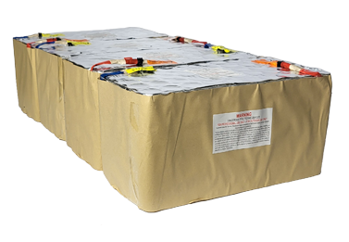
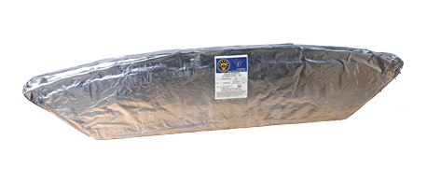

4 Professional Use Only Firework – Fan/Slice 5 Professional Use Only Firework – Compound Cake

The items pictured above are examples of how not all items can necessarily be identified at a glance and be assumed to be Consumer Fireworks available for sale to the consumer general public. Typically, Consumer Fireworks are in brightly colored labels with logos and other branding clearly visible and promoted (refer to the above picture 1) or in the plain wrapper as seen in picture 3 noted above.
Professional Use Only Fireworks and Articles Pyrotechnic should not be decorated and come with different warnings on them (refer to the above picture 2,4,5). Again, it is important to emphasize that there are some Consumer Fireworks that are packaged in plain, less colorful, wrappers as noted in the preceding paragraphs. Therefore, proper identification MUST revert to the WARNING label.
Summarizing - The item on the left bottom of page 4 is a UN0336, 1.4G Firework (Consumer). The center item (same page) is a UN0431, 1.4G Articles Pyrotechnic. Under prior transport classification additions by PHMSA/DOT similar type items could also be classified and labeled as UN0336 1.4G, Fireworks – For Professional Use Only. Like the image on the bottom left of page 4, the image on the bottom right of page 4 is also a UN0336, 1.4G, Firework (Consumer). One can see that just a quick glance at a firework item is not necessarily enough to provide the business owner or AHJ with enough information. Rather, a more detailed inspection of the WARNING and other labels on the item is necessary.
Section 5: In Closing
Whether you are a consumer, business owner or the local AHJ, it is important to know what type of firework devices you are looking at. Another reference text available is the American Fireworks Standards Laboratory Standards for Consumer Fireworks which contains (or exceeds) the specific 16 CFR requirements for the various types of Consumer Fireworks and shows examples of the specific labelling for each type of device.

Per CPSC reference –the Federal Hazardous Substances Act (FHSA) is part of the Code of Federal Regulations (CFR). Specifically referenced as 16 CFR Part 1500. General requirements on warning label prominence, placement and conspicuousness can be found in 16 CFR Part 1500 section 121. Fireworks specific requirements can be found in 16 CFR Parts 1500.14 and Part 1500.83(a)(27).

